# Drop Missing Percentage Returns

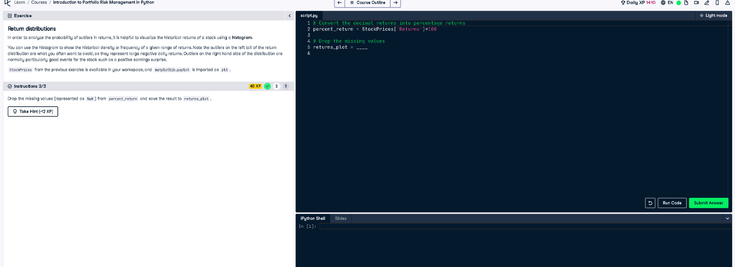

## Python Code

# Convert the decimal returns into percentage returns  
percent_return = StockPrices['Returns'] * 100  
  
# Drop the missing values  
returns_plot = percent_return.dropna()

## Explanation

This code removes missing values (NaN) from the percent_return data using .dropna() and stores the cleaned data in returns_plot. This is important for plotting or further analysis because NaN values can cause errors or distort visualizations like histograms, which require complete numerical data.